Xiaoxu Na

Q1

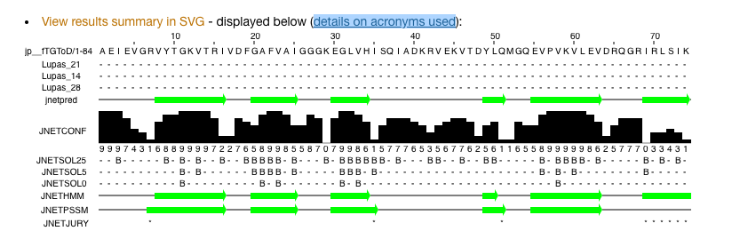

The green arrow parts are the sheets and JNETCONF shows the most confident parts.

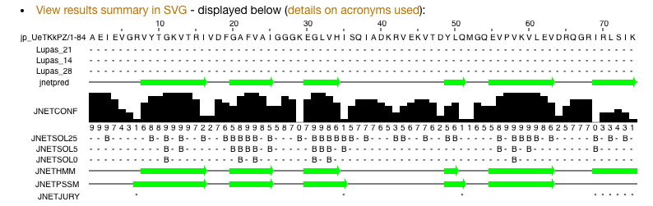

Q2



1sro_A matches the best.